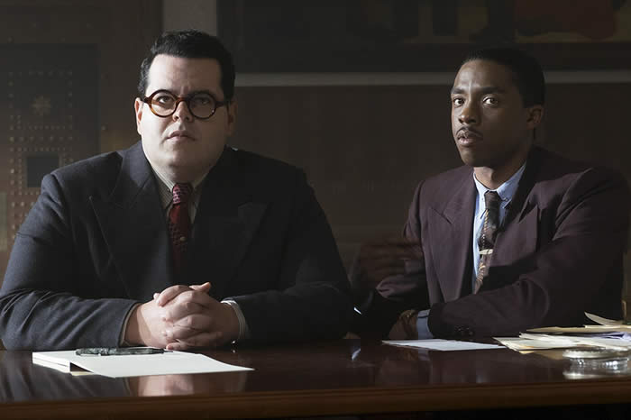
Marshall
Reginald Hudlin’s look back at an early case in the
career of eventual Supreme Court Justice Thurgood
Marshall is as downright entertaining as it is sadly historic...
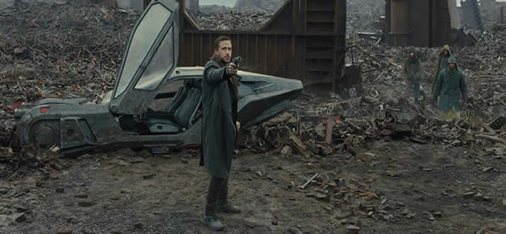
Blade Runner 2049
This worthy sequel is a feast for the eyes and ears. The heart? Not so much....
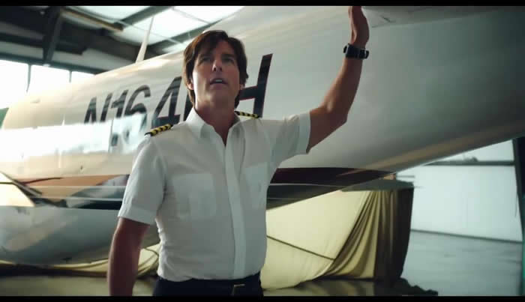
American Made
Tom Cruise gives his best performance in years
in a film almost too intently nuts to notice...

Kingsman: The Golden Circle
It’s been a while since Hollywood worked this hard to make us have a good time.
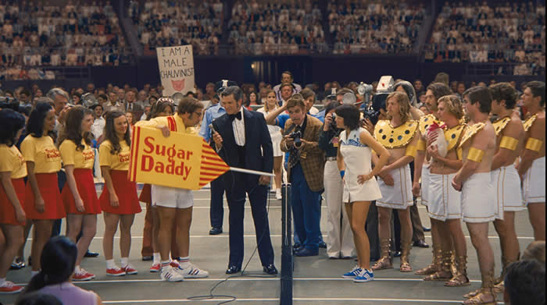
Battle of the Sexes
Have we really come a long way, baby?
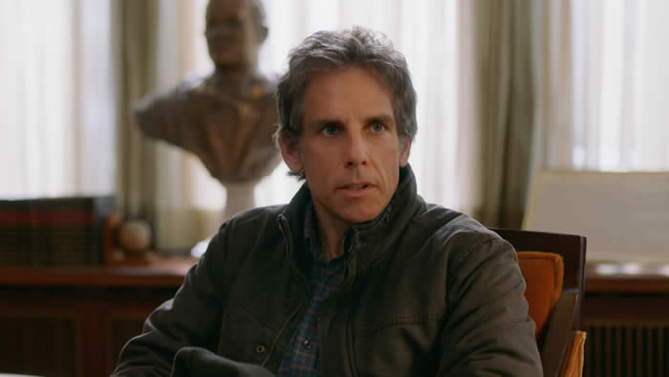
Brad's Status
No, you don’t have to be a middle aged father college road
tripping with his son to feel how wonderful Mike White’s gentle
comedy is: you just have to have an open heart and soul...
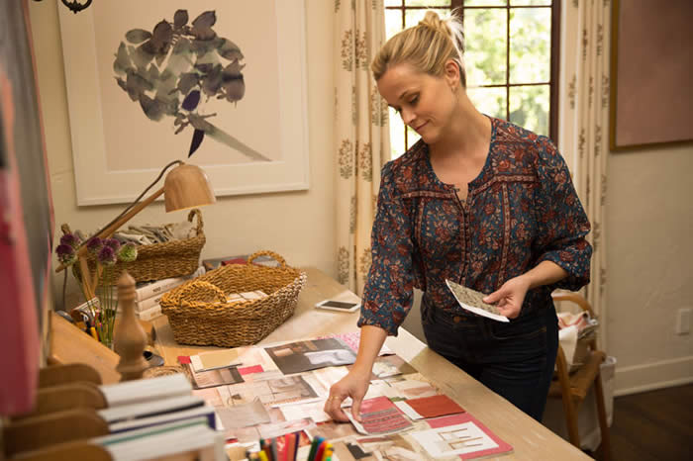
Home Again
Yes, I’d hoped Hallie Meyers-Shyer would deliver the
kind of warm and wise romantic comedy her mother
used to make and I guess she tried, but...
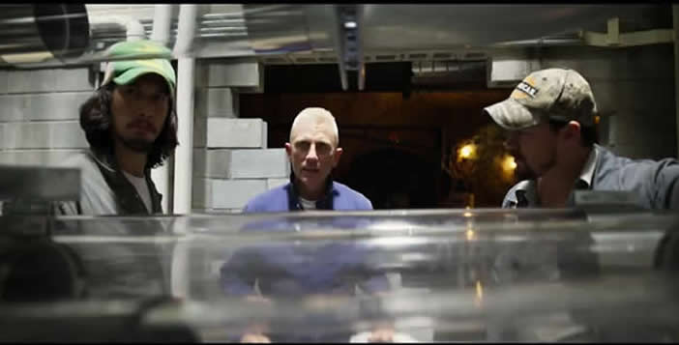
Logan Lucky
Steven Soderburgh’s return to the big screen
may look like an Ocean’s reboot a la NASCAR, but don’t
you go thinking this is some smart alecky snobby spin...
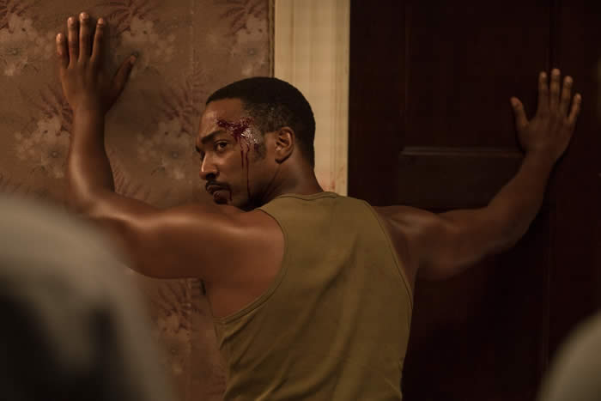
Detroit
Katherine Bigelow’s powerful testament reminds us not just of our history,
but, especially in light of recent events, makes us wonder if we, indeed, have learned anything from it.

